Ideation Phase
Brainstorm & Idea Prioritization Template

Date | 19 July 2026
Team ID
Project Name | Nightjar & Co. – MERN BookStore
Maximum Marks | 4 Marks

BRAIN STORMING AND IDEATION PHASE
Step 1: Team Gathering, Collaboration and Select the Problem Statement
Team Members
- Trisha (Team Lead)
- Anjali
- Deepika
- Pranathi
- Sajida
Problem Statement
Many readers face difficulty in discovering books, comparing categories, and purchasing books through a simple and user-friendly platform. Traditional bookstores have limited accessibility, while many online platforms are complex or lack personalized browsing features.
After discussing different project ideas, the team selected the Nightjar & Co. – MERN BookStore because it addresses these challenges by providing an easy-to-use online bookstore with secure authentication, search, category filtering, cart management, and order placement.
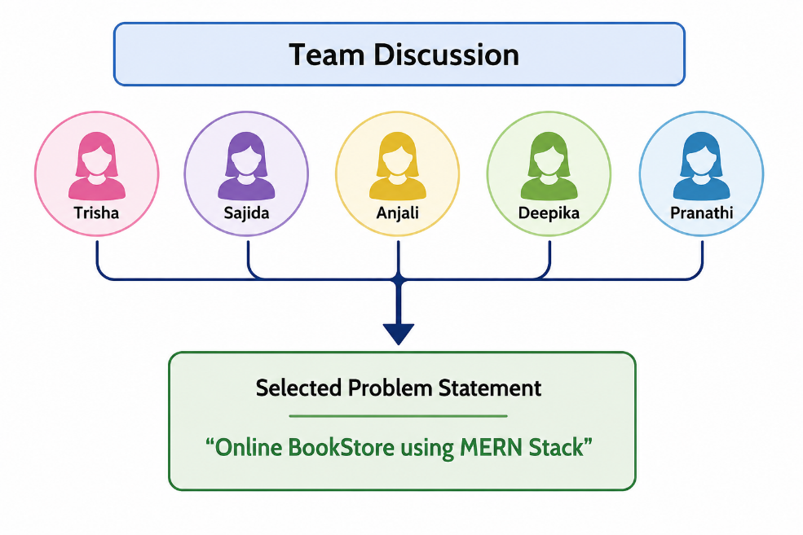

Step 2: Brainstorm, Idea Listing and Grouping
The team generated multiple ideas before finalizing the project features. Similar ideas were grouped together to identify the most valuable functionality for users.
Ideas Generated
Category | Ideas
User Features | Login, Registration, Profile
Book Features | Browse Books, Search Books, Categories
Shopping | Cart, Checkout, Orders
Admin | Add Books, Update Books, Delete Books
Security | JWT Authentication
Technology | MongoDB, Express.js, React, Node.js

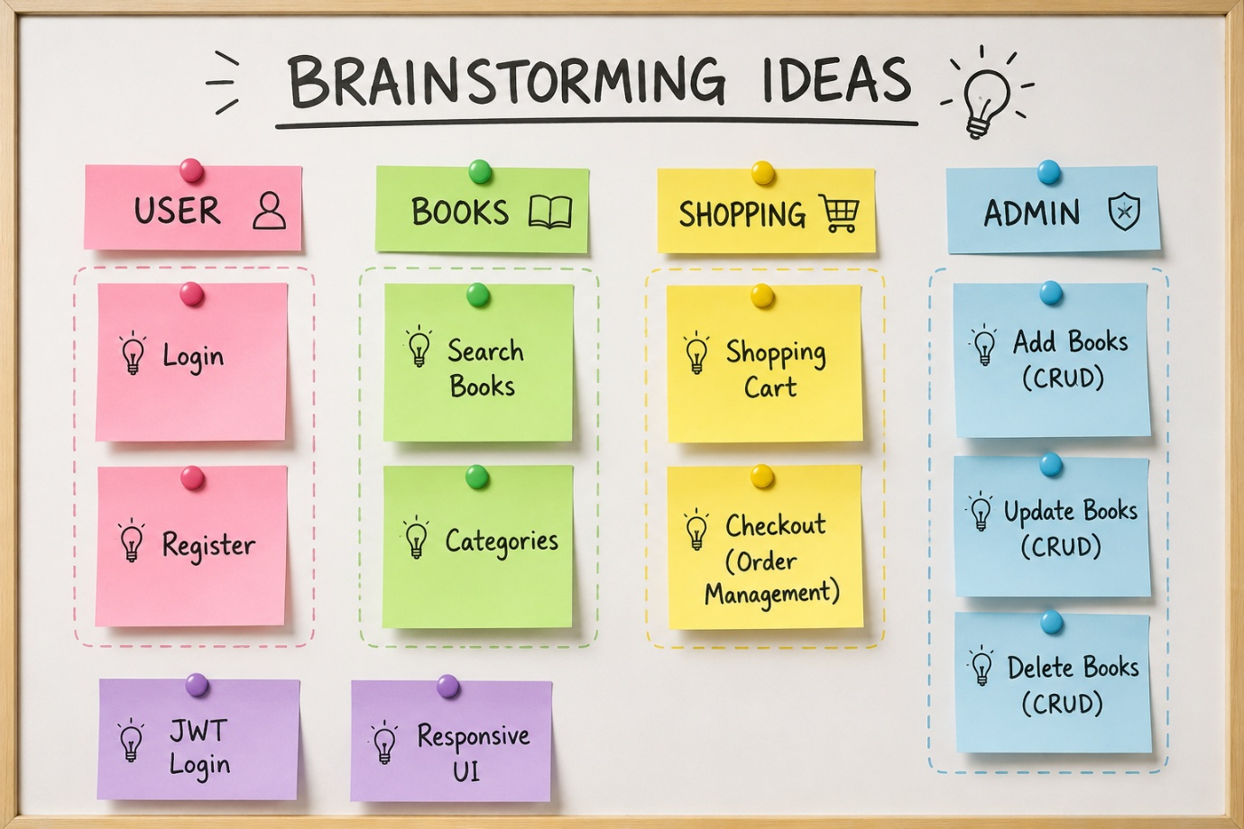

Step 3: Idea Prioritization
The team evaluated all proposed ideas based on importance, feasibility, and user value. High-priority features were selected for the first version of the application.
Feature | Priority
User Authentication | High
Book Catalog | High
Search & Filter | High
Shopping Cart | High
Checkout | Medium
Book Reviews | Medium
Wishlist | Low
AI Recommendation | Low

